

ECG EBS3 migrate to EBS4 Sprint1 Deploy Document

Version number: 1.0

Version Control
Effective Date: | 27 Nov. 2017
Supersedes Previous Document:
Latest Revision Date: | 29 Nov. 2017
Prepared By: | Eddie Cheng
Version Number: | 1.1
Document Reference Number:

Table of Content
ECG EBS3 migrate to EBS4 Sprint1 Deploy Document 1
Version Control 2
Table of Content 3
1. Preparation 4
2. Execute SQL 5
3. Manual 7
4. Annex 9

Preparation
- Data paths：
SVN paths (inline): https://172.30.1.129/svn/EG_GZ_IT_Rep/ECG_EBS4/branches/ESL_2_0_35_sprint1/dbScript/Sprint01/
Database name：ESL_Dev

- Download and decompress file named Sprint01_20171129.zip，files would be listed like below：

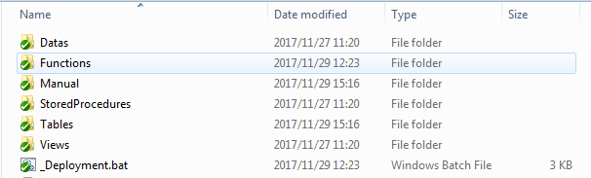

Execute SQL
- Execute SQL Script
- Please backup your local database to avoid accidents: ESL_Dev
- Right click file “_Deployment.bat” with notepad, check your Database IP, Database name, Database username and password, update and save _Deployment.bat with them.

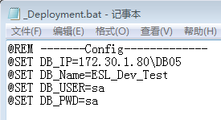

Here it is the application configuration in local, IP, Database name, Database username and password we used above in “_Deployment.bat”。

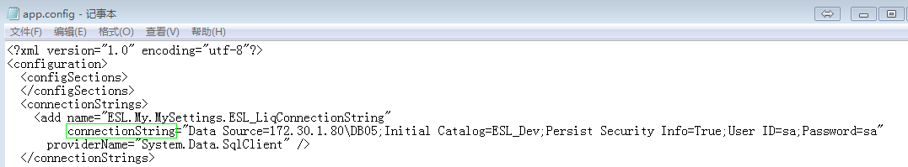

Once it runs successful, it shows result below:

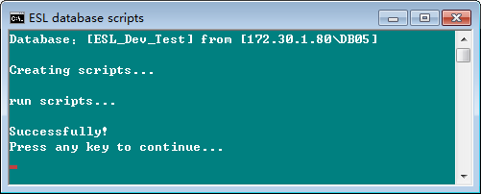

Once it runs fail, here it is the result you would get:

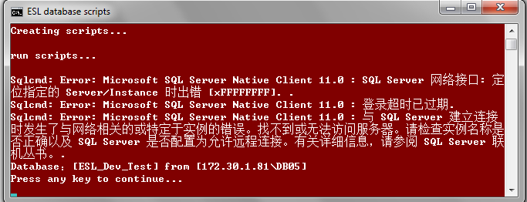
Notes: since local database is used Simplified-Chinese version, you can see error with different languages above. Language of error catches from database would be the same as your local version.

After running fail, the SQL exception errors would be saved into “_Deployment[xxxx].log”, please send logs to us, we would help you fix the issues.

Manual
- Execute SQL Script manually: Alter_exchangerate_AddUniqueKey.sql
The script named “Alter_exchangerate_AddUniqueKey.sql” need to be executed manually, which in the folder named “Manual”:

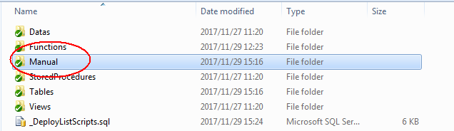

1) Execute Step 1 script to check duplicate data.
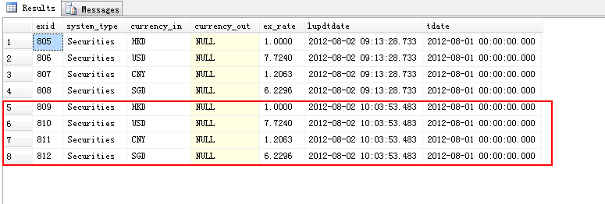
2) Update Step 2_lupdtdate, then Execute Step 2 script to check which data is not correct and should be deleted
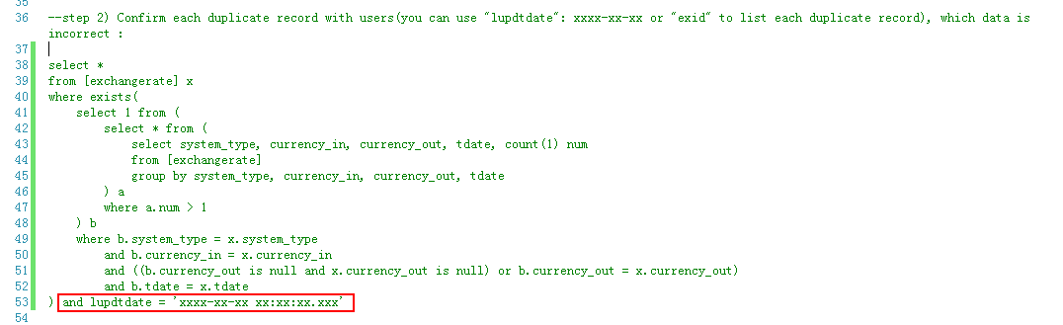

3) If need to delete duplicate data, update Step 3_lupdtdate = Step 2_lupdtdate, then Execute Step 3 script. If there is no duplicate data, skip please.
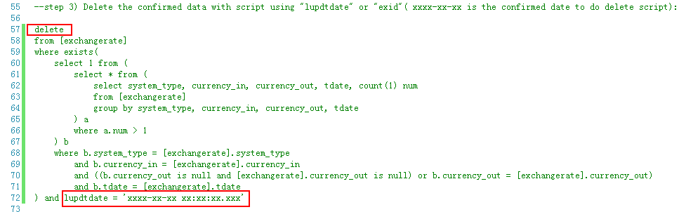

4) Execute Step 4 script to add unique key.

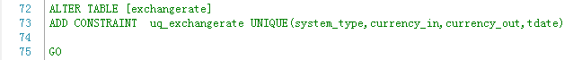

Annex
Annex information about deployment
Emergency contact
姓名 | 聯繫電話 | 角色
Eddie Cheng | (+852) 2709 8173 / Direct 3103 | Dev Team

